

Ice Cream Shop

Management System

a sql project

FALL 2022

Introduction To Database [SECTION- H]

DATE OF SUBMISSION: 12 Dec, 2022

**ProJect Title :** AN ice cream shop management system

|  |  |
| --- | --- |
| Name | Id |
| tahsin, md tasmim al | 22-46299-1 |
| hossain, mir md mofakkar | 22-46245-1 |
| Tanzil, Md rayhan | 22-46300-1 |

**Submitted by**

**GROUP: 2**

**instructed by**

SIFAT RAHMAN AHONA

###### Assistant Professor, Computer Science

AMERICAN INTERNATIONAL UNIVERSITY – BANGLADESH

TABLE OF CONTENTS

|  |  |
| --- | --- |
| * CASE STUDY | 3 |
| * ER DIAGRAM | 4 |
| * NORMALIZATION | 5 |
| * TABLE CREATION | 12 |
| * DATA INSERTION | 21 |
| * CONSTRAINTS ADDING | 33 |
| * QUERY WRITING | 35 |

CASE STUDY

# Introduction:

A method for systematically managing an ice-cream shops daily commodities is called an ice-cream shop management system. This system's primary benefit is that it makes managing the business a lot easier. Reduced manual labor and increased workplace productivity can execute through this management system. The everyday flow of services and orders is aided by this method.

# Scenario Description:

Ice-cream shop management system offers an efficient working system for the shop. The shop has Menu in their system where food_name, food_id, Price, and the status of a food is stored. A customer can request menu details. One customer can submit a single order. A customer is identified as customer_id, customer_name, customer_address, and contact_number. However, customers can give ratings on the menu. Rating has unique rating_id, score, remarks and comment. Orders details are associated with order_id, order_date, amount, total_amount and order_details. When a customer completes an order, then they process their payments like payment_id, amount, paid_by, discount, and date. An ice_cream shop management system has many waiters to serve food. The attributes for the waiters are waiter_id, waiter_name, waiter_address, phone_number, salary, and role. Each order should produce one serve, and each serve is conducted by one waiter. Also, there are some employees to run the shops other commodities. Their attributes are employee_id, employee_name, employee_address, phone_number,salary and their role. The waiters and employees work under a manager and the managers name, address, phone_number and salary is also stored in the system.

ER DIAGRAM

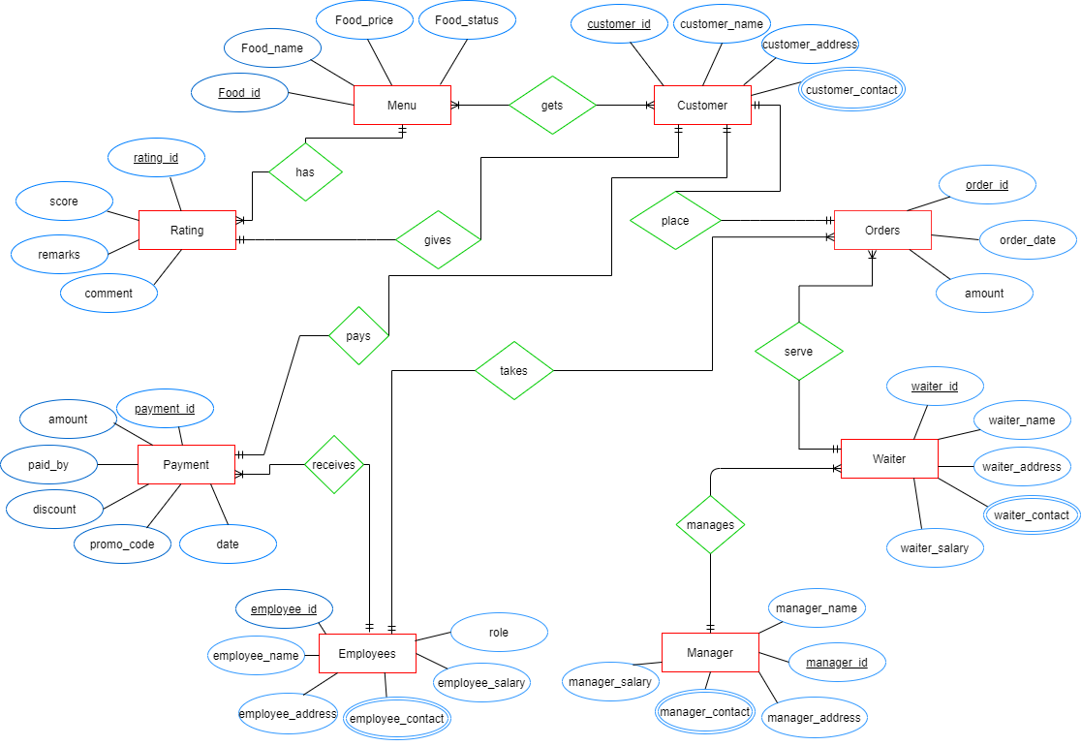

NORMALIZATION

Gets (Food_id, Food_name, Food_status, Price, Customer_id, Customer_name, Customer_address, Customer_contact)

**1NF:** Customer_contact Multivalued Attribute

**2NF:** Food_id, Food_name, Food_status, Price

Customer_id, Customer_name, Customer_address, Customer_contact

CF_id, Customer_id, Food_id

**3NF:** There is no Transitive Dependency.

Food_id, Food_name, Food_status, Price

Customer_id, Customer_name, Customer_address, Customer_contact

CF_id, Customer_id, Food_id

**TABLE:**

Food_id, Food_name, Food_status, Price

Customer_id, Customer_name, Customer_address, Customer_contact

CF_id, Customer_id, Food_id

Place (Order_id, Order_date, Amount, Customer_id, Customer_name, Customer_address, Customer_contact)

**1NF:** Customer_contact Multivalued Attribute

**2NF:** Order_id, Order_date, Amount

Customer_id, Customer_name, Customer_address, Customer_contact, Order_id

**3NF:** There is no Transitive Dependency.

Order_id, Order_date, Amount, Customer_id

Customer_id, Customer_name, Customer_address, Customer_contact, Order_id

**TABLE:**

Order_id, Order_date, Amount, Customer_id

Customer_id, Customer_name, Customer_address, Customer_contact, Order_id

Serve (Order_id, Order_date, Amount, Waiter_id, Waiter_name, Waiter_address, Waiter_contact, Waiter_salary)

**1NF:** Waiter_contact Multivalued Attribute

**2NF:** Order_id, Order_date, Amount, Waiter_id

Waiter_id, Waiter_name, Waiter_address, Waiter_contact, Waiter_salary

**3NF:** There is no Transitive Dependency.

Order_id, Order_date, Amount, Waiter_id

Waiter_id, Waiter_name, Waiter_address, Waiter_contact, Waiter_salary

**TABLE:**

Order_id, Order_date, Amount, Waiter_id

Waiter_id, Waiter_name, Waiter_address, Waiter_contact, Waiter_salary

Manages (Manager_id, Manager_name, Manager_address, Manager_salary, Manager_contact, Waiter_id, Waiter_name, Waiter_address, Waiter_contact, Waiter_salary)

**1NF:** Manager_contact, Waiter_contact Multivalued Attribute

**2NF:** Manager_id, Manager_name, Manager_address, Manager_salary, Manager_contact Waiter_id, Waiter_name, Waiter_address, Waiter_contact, Waiter_salary, Manager_id

**3NF:** There is no Transitive Dependency.

Manager_id, Manager_name, Manager_address, Manager_salary, Manager_contact

Waiter_id, Waiter_name, Waiter_address, Waiter_contact, Waiter_salary, Manager_id

**TABLE:**

Manager_id, Manager_name, Manager_address, Manager_salary, Manager_contact

Waiter_id, Waiter_name, Waiter_address, Waiter_contact, Waiter_salary, Manager_id

Takes (Order_id, Order_date, Amount, Employee_id, Employee_name, Employee _address, Employee_contact, Employee_salary, role)

**1NF:** Employee_contact Multivalued Attribute

**2NF:** Order_id, Order_date, Amount, Employee_id

Employee_id, Employee_name, Employee _address, Employee_contact, Employee_salary, role

**3NF:** There is no Transitive Dependency.

Order_id, Order_date, Amount, Employee_id

Employee_id, Employee_name, Employee _address, Employee_contact, Employee_salary, role

**TABLE:**

Order_id, Order_date, Amount, Employee_id

Employee_id, Employee_name, Employee _address, Employee_contact, Employee_salary, role

Receives (Payment_id, Amount, Paid_by, Discount, Promo_code, Date, Employee_id, Employee_name, Employee _address, Employee_contact, Employee_salary, role)

**1NF:** Employee_contact Multivalued Attribute

**2NF:** Payment_id, Amount, Paid_by, Discount, Promo_code, Date, Employee_id

Employee_id, Employee_name, Employee _address, Employee_contact, Employee_salary, role

**3NF:** There is no Transitive Dependency.

Payment_id, Amount, Paid_by, Discount, Promo_code, Date, Employee_id

Employee_id, Employee_name, Employee _address, Employee_contact, Employee_salary, role

**TABLE:**

Payment_id, Amount, Paid_by, Discount, Promo_code, Date

Employee_id, Employee_name, Employee _address, Employee_contact, Employee_salary, role

Pays (Payment_id, Amount, Paid_by, Discount, Promo_code, Date, Customer_id, Customer_name, Customer_address, Customer_contact)

**1NF:** Customer_contact Multivalued Attribute

**2NF:** Payment_id, Amount, Paid_by, Discount, Promo_code, Date, Customer_id

Customer_id, Customer_name, Customer_address, Customer_contact

**3NF**: There is no Transitive Dependency.

Payment_id, Amount, Paid_by, Discount, Promo_code, Date, Customer_id

Customer_id, Customer_name, Customer_address, Customer_contact

**TABLE:**

Payment_id, Amount, Paid_by, Discount, Promo_code, Date, Customer_id

Customer_id, Customer_name, Customer_address, Customer_contact

Gives (Rating_id, Score, Remarks, Comment, Customer_id, Customer_name, Customer_address, Customer_contact)

**1NF**: Customer_contact Multivalued Attribute

**2NF:** Rating_id, Score, Remarks, Comment, Customer_id

Customer_id, Customer_name, Customer_address, Customer_contact

**3NF:** There is no Transitive Dependency.

Rating_id, Score, Remarks, Comment, Customer_id

Customer_id, Customer_name, Customer_address, Customer_contact

**TABLE:**

Rating_id, Score, Remarks, Comment, Customer_id

Customer_id, Customer_name, Customer_address, Customer_contact

Has (Food_id, Food_name, Food_status, Price, Rating_id, Score, Remarks, Comment)

**1NF:** No Multivalued Attribute

**2NF:** Food_id, Food_name, Food_status, Price

Rating_id, Score, Remarks, Comment, Food_id

**3NF:** There is no Transitive Dependency.

Food_id, Food_name, Food_status, Price

Rating_id, Score, Remarks, Comment, Food_id

**TABLE:**

Food_id, Food_name, Food_status, Price

Rating_id, Score, Remarks, Comment, Food_id

**TOTAL TABLE:**

1. Food_id, Food_name, Food_status, Price
2. ~~Customer_id, Customer_name, Customer_address, Customer_contact~~
3. CF_id, Customer_id, Food_id
4. ~~Order_id, Order_date, Amount~~
5. Customer_id, Customer_name, Customer_address, Customer_contact, Order_id
6. Order_id, Order_date, Amount, Waiter_id
7. ~~Waiter_id, Waiter_name, Waiter_address, Waiter_contact, Waiter_salary~~
8. Manager_id, Manager_name, Manager_address, Manager_salary, Manager_contact
9. Waiter_id, Waiter_name, Waiter_address, Waiter_contact, Waiter_salary, Manager_id
10. Order_id, Order_date, Amount, Employee_id
11. Employee_id, Employee_name, Employee _address, Employee_contact, Employee_salary, role
12. ~~Payment_id, Amount, Paid_by, Discount, Promo_code, Date~~
13. ~~Employee_id, Employee_name, Employee _address, Employee_contact, Employee_salary, role~~
14. Payment_id, Amount, Paid_by, Discount, Promo_code, Date, Customer_id
15. ~~Customer_id, Customer_name, Customer_address, Customer_contact~~
16. Rating_id, Score, Remarks, Comment, Customer_id
17. ~~Customer_id, Customer_name, Customer_address, Customer_contact~~
18. ~~Food_id, Food_name, Food_status, Price~~
19. Rating_id, Score, Remarks, Comment, Food_id

**FINAL TABLE:**

1. Food_id, Food_name, Food_status, Price
2. CF_id, Customer_id, Food_id
3. Customer_id, Customer_name, Customer_address, Customer_contact, Order_id
4. Order_id, Order_date, Amount, Waiter_id
5. Manager_id, Manager_name, Manager_address, Manager_salary, Manager_contact
6. Waiter_id, Waiter_name, Waiter_address, Waiter_contact, Waiter_salary, Manager_id
7. Order_id, Order_date, Amount, Employee_id
8. Employee_id, Employee_name, Employee _address, Employee_contact, Employee_salary, role
9. Payment_id, Amount, Paid_by, Discount, Promo_code, Date, Customer_id
10. Rating_id, Score, Remarks, Comment, Customer_id
11. Rating_id, Score, Remarks, Comment, Food_id

TABLE CREATION

MENU

create table Menu(Food_id number(10) primary key, Food_name varchar2(40), Food_status varchar2(20), Price number(10))

create sequence menuseq

start with 1

increment by 1

maxvalue 500

NOCACHE

NOCYCLE

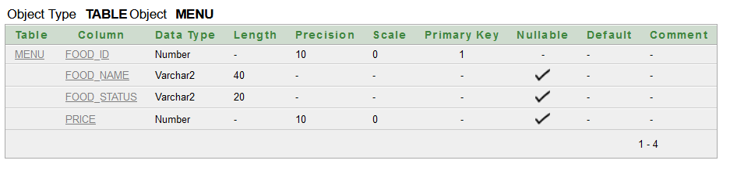

CUSTOMER

create table Customer(Customer_id number(10) primary key, Customer_name varchar2(40), Customer_address varchar2(50), Customer_contact number(20), Order_id number(10))

create sequence customerseq

start with 1

increment by 1

maxvalue 500

NOCACHE

NOCYCLE

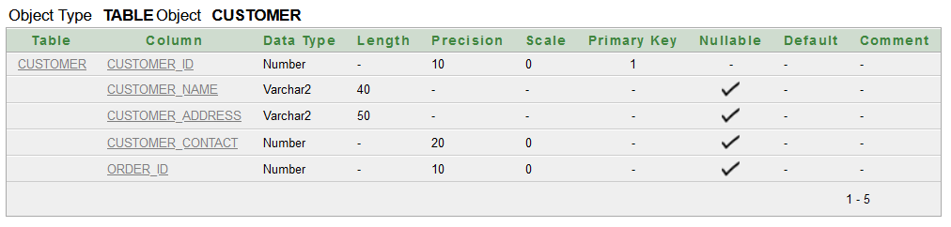

MANAGER

create table Manager(Manager_id number(10) primary key, Manager_name varchar2(30), Manager_address varchar2(50), Manager_salary number(10), Manager_contact number(20))

create sequence managerseq

start with 1

increment by 1

maxvalue 500

NOCACHE

NOCYCLE

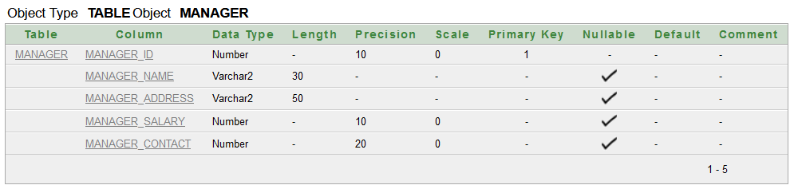

EMPLOYEE

create table Employee(Employee_id number(10) primary key, Employee_name varchar2(30), Employee_address varchar2(50), Employee_contact number(20), Employee_salary number(10), role varchar2(20))

create sequence employeeseq

start with 1

increment by 1

maxvalue 500

NOCACHE

NOCYCLE

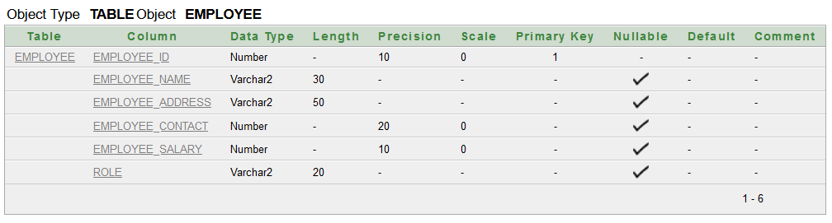

WAITER

create table Waiter (waiter_id number(10) primary key, waiter_name varchar2(30),waiter_address varchar2(50), waiter_contact number(20), waiter_salary number(10), manager_id number(10))

create sequence waiterseq

start with 1

increment by 1

maxvalue 500

NOCACHE

NOCYCLE

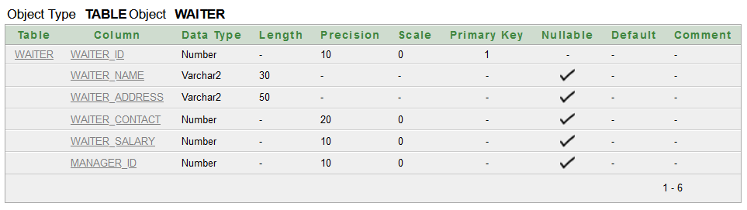

PAYMENT

create table Payment(payment_id number(10) primary key, amount number(10), paid_by varchar2(30), discounts number(10), promo_code number(10), dates varchar2(10), customer_id number(10))

create sequence paymentseq

start with 1

increment by 1

maxvalue 500

NOCACHE

NOCYCLE

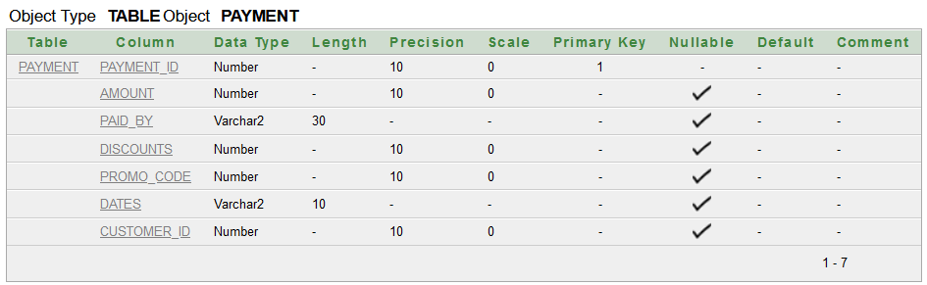

RATING

create table Rating(Rating_id number(10) primary key, Scores number(10), Remarks varchar2(100), Comments varchar2(100), Customer_id number(10), Food_id number(10))

create sequence ratingseq

start with 1

increment by 1

maxvalue 500

NOCACHE

NOCYCLE

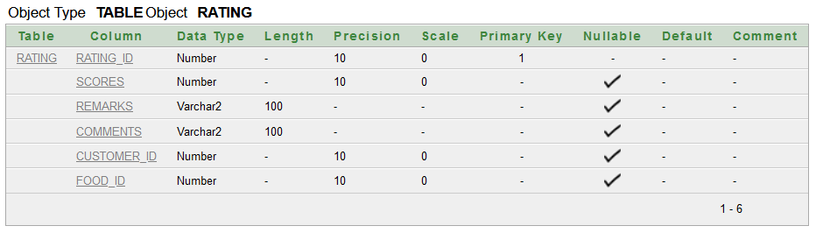

ORDERS

create table Orders(Order_id number(10) primary key, Order_date varchar2(20), Amount number(10), Waiter_id number(10), Employee_id number(10))

create sequence orderseq

start with 1

increment by 1

maxvalue 500

NOCACHE

NOCYCLE

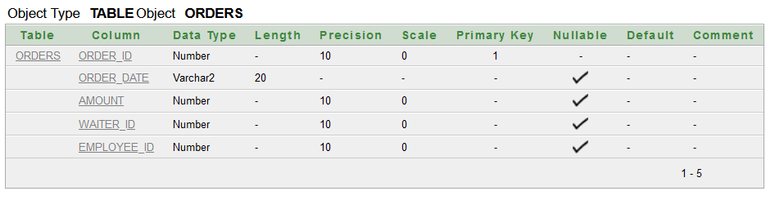

CMR

create table CMR(CF_id number(10) primary key, customer_id number(10), food_id number(10))

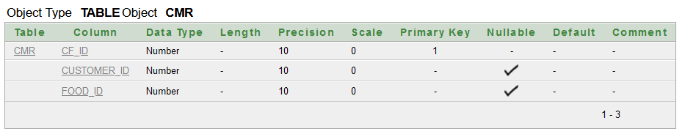

DATA INSERTION

MENU

INSERT INTO Menu VALUES(menuseq.NEXTVAL, 'CHOCOLATE ICECREAM', 'AVAILABLE', 160);

INSERT INTO Menu VALUES(menuseq.NEXTVAL, 'VANILLA ICECREAM', 'AVAILABLE', 120);

INSERT INTO Menu VALUES(menuseq.NEXTVAL, 'PEANUT BUTTER ICECREAM', 'AVAILABLE', 199);

INSERT INTO Menu VALUES(menuseq.NEXTVAL, 'CINNAMON ICECREAM', 'AVAILABLE', 220);

INSERT INTO Menu VALUES(menuseq.NEXTVAL, 'STRAWBERRY ICECREAM', 'AVAILABLE', 180);

INSERT INTO Menu VALUES(menuseq.NEXTVAL, 'CARAMEL ICECREAM', 'AVAILABLE', 220);

INSERT INTO Menu VALUES(menuseq.NEXTVAL, 'BANANA ICECREAM', 'AVAILABLE', 120);

INSERT INTO Menu VALUES(menuseq.NEXTVAL, 'MINT ICECREAM', 'AVAILABLE', 190)

INSERT INTO Menu VALUES(menuseq.NEXTVAL, 'BUTTER ICECREAM', 'AVAILABLE', 220);

INSERT INTO Menu VALUES(menuseq.NEXTVAL, 'CHERRY ICECREAM', 'AVAILABLE', 220);

INSERT INTO Menu VALUES(menuseq.NEXTVAL, 'KIWI ICECREAM', 'AVAILABLE', 280);

INSERT INTO Menu VALUES(menuseq.NEXTVAL, 'MELON MIX', 'AVAILABLE', 250);

INSERT INTO Menu VALUES(menuseq.NEXTVAL, 'YOUGURT', 'AVAILABLE', 200);

INSERT INTO Menu VALUES(menuseq.NEXTVAL, 'CREAMY MILK', 'AVAILABLE', 200);

INSERT INTO Menu VALUES(menuseq.NEXTVAL, 'MANGO ICECREAM', 'AVAILABLE', 190);

INSERT INTO Menu VALUES(menuseq.NEXTVAL, 'CHOCOLATE CONE', 'AVAILABLE', 199);

INSERT INTO Menu VALUES(menuseq.NEXTVAL, 'STRAWBERRY CONE', 'AVAILABLE', 220);

INSERT INTO Menu VALUES(menuseq.NEXTVAL, 'SUGER CONE', 'AVAILABLE', 180);

INSERT INTO Menu VALUES(menuseq.NEXTVAL, 'WAFER CONE', 'UNAVAILABLE', 320);

INSERT INTO Menu VALUES(menuseq.NEXTVAL, 'RASPBERRY ICECREAM', 'AVAILABLE', 380);

INSERT INTO Menu VALUES(menuseq.NEXTVAL, 'HOT CHOCOLATE', 'AVAILABLE', 190);

INSERT INTO Menu VALUES(menuseq.NEXTVAL, 'VANILLA MILKSHAKE', 'AVAILABLE', 120);

INSERT INTO Menu VALUES(menuseq.NEXTVAL, 'CHOCOLATE MILKSHAKE', 'AVAILABLE', 149);

INSERT INTO Menu VALUES(menuseq.NEXTVAL, 'STRAWBERRY MILKSHAKE', 'AVAILABLE', 149);

INSERT INTO Menu VALUES(menuseq.NEXTVAL, 'ORANGE SMOOTHIE', 'AVAILABLE', 99);

INSERT INTO Menu VALUES(menuseq.NEXTVAL, 'KIWI SMOOTHIE', 'AVAILABLE', 120);

INSERT INTO Menu VALUES(menuseq.NEXTVAL, 'CHOCOLATE SMOOTHIE', 'AVAILABLE', 99);

INSERT INTO Menu VALUES(menuseq.NEXTVAL, 'STRAWBERRY SMOOTHIE', 'AVAILABLE', 99);

INSERT INTO Menu VALUES(menuseq.NEXTVAL, 'BIRTHDAY SURPRISE', 'AVAILABLE', 899);

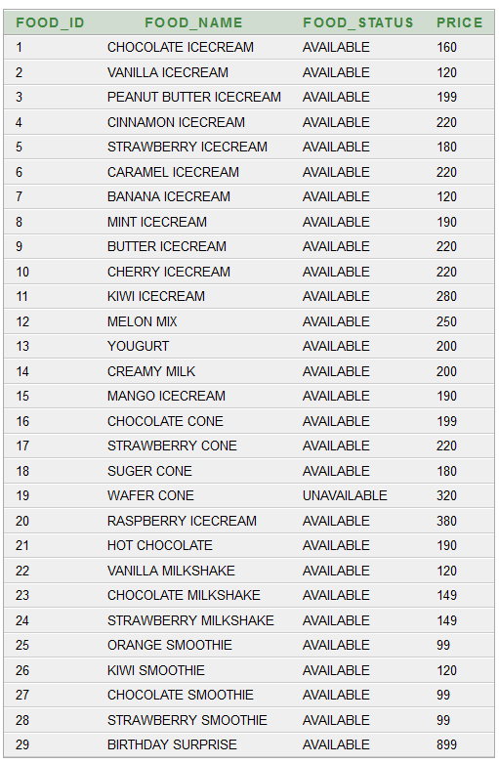

CUSTOMER

INSERT INTO Customer VALUES(customerseq.NEXTVAL, 'RAYHAN', 'UTTARA, DHAKA', 8801884801110, 1);

INSERT INTO Customer VALUES(customerseq.NEXTVAL, 'TAMIM', 'BANANI, DHAKA', 8801884871110, 2);

INSERT INTO Customer VALUES(customerseq.NEXTVAL, 'NIHAB', 'BANANI, DHAKA', 8801884801189, 3);

INSERT INTO Customer VALUES(customerseq.NEXTVAL, 'LIMA', 'KURIL, DHAKA', 8801884878110, 4);

INSERT INTO Customer VALUES(customerseq.NEXTVAL, 'HIMEL', 'UTTARA, DHAKA', 8801884801120, 5);

INSERT INTO Customer VALUES(customerseq.NEXTVAL, 'AKASH', 'UTTARA, DHAKA', 8801884801130, 6);

INSERT INTO Customer VALUES(customerseq.NEXTVAL, 'RIVA', 'BADDA, DHAKA', 8801884801140, 7);

INSERT INTO Customer VALUES(customerseq.NEXTVAL, 'JIBON', 'FARMGATE, DHAKA', 8801884801150, 8);

INSERT INTO Customer VALUES(customerseq.NEXTVAL, 'FAHIM', 'NIKUNJA, DHAKA', 8801884801160, 9);

INSERT INTO Customer VALUES(customerseq.NEXTVAL, 'MEHEDI', 'BASHUNDHARA, DHAKA', 8801884801170, 10);

INSERT INTO Customer VALUES(customerseq.NEXTVAL, 'SHAMMO', 'BASHUNDHARA, DHAKA', 8801884801180, 11);

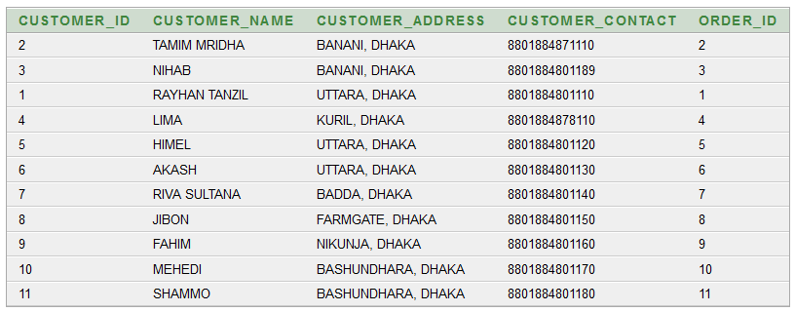

MANAGER

INSERT INTO Manager VALUES(managerseq.NEXTVAL, 'MOFAKKAR', 'CHITTAGONG',25000, 8801478988574);

INSERT INTO Manager VALUES(managerseq.NEXTVAL, 'RAYHAN', 'DHAKA',25000, 8801478988577);

INSERT INTO Manager VALUES(managerseq.NEXTVAL, 'NIYAN', 'DHAKA',25000, 8801478988584);

INSERT INTO Manager VALUES(managerseq.NEXTVAL, 'RABBI', 'BARISHAL',25000, 8801478988585);

INSERT INTO Manager VALUES(managerseq.NEXTVAL, 'ROFIQ', 'DHAKA',25000, 8801478988587);

INSERT INTO Manager VALUES(managerseq.NEXTVAL, 'TANHA', 'DHAKA',25000, 8801478988589);

INSERT INTO Manager VALUES(managerseq.NEXTVAL, 'TOUFIQ', 'TANGAIL',25000, 88014789885890);

INSERT INTO Manager VALUES(managerseq.NEXTVAL, 'NASIR', 'DHAKA',25000, 8801478988592);

INSERT INTO Manager VALUES(managerseq.NEXTVAL, 'JAFAR', 'DHAKA',35000, 8801478988595);

INSERT INTO Manager VALUES(managerseq.NEXTVAL, 'SAIF', 'DHAKA',20000, 8801478988598);

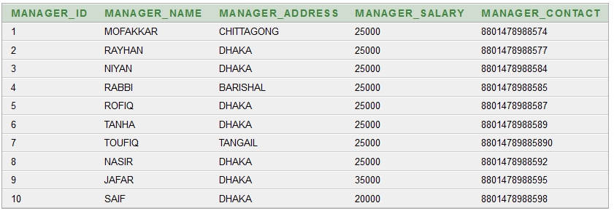

EMPLOYEE

INSERT INTO Employee VALUES(employeeseq.NEXTVAL, 'ALEX', 'DHAKA', 8801758998454, 10000, 'CASHIER');

INSERT INTO Employee VALUES(employeeseq.NEXTVAL, 'HALES', 'DHAKA', 8801758998455, 8000, 'CLEANER');

INSERT INTO Employee VALUES(employeeseq.NEXTVAL, 'TRUMP', 'CHITTAGONG', 8801758998456, 15000, 'GUARD');

INSERT INTO Employee VALUES(employeeseq.NEXTVAL, 'PUTIN', 'BARISHAL', 8801758998457, 15000, 'GUARD');

INSERT INTO Employee VALUES(employeeseq.NEXTVAL, 'MIKEL', 'DHAKA', 8801758998458, 8000, 'CLEANER');

INSERT INTO Employee VALUES(employeeseq.NEXTVAL, 'JACK', 'GAZIPUR', 8801758998459, 8000, 'CLEANER');

INSERT INTO Employee VALUES(employeeseq.NEXTVAL, 'JAY', 'BANANI', 8801758998460, 8000, 'CLEANER');

INSERT INTO Employee VALUES(employeeseq.NEXTVAL, 'ROBIN', 'DHAKA', 8801758998461, 15000, 'GUARD');

INSERT INTO Employee VALUES(employeeseq.NEXTVAL, 'ARIF', 'DHAKA', 8801758998462, 10000, 'CASHIER');

INSERT INTO Employee VALUES(employeeseq.NEXTVAL, 'BOB', 'SYLHET', 8801758998463, 10000, 'CASHIER');

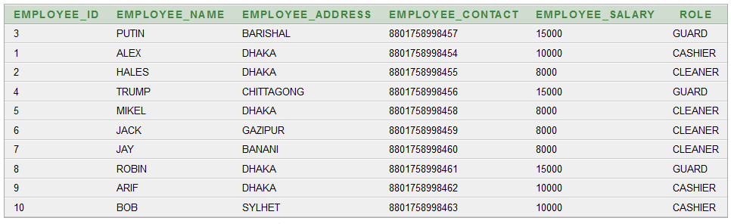

WAITER

INSERT INTO Waiter VALUES(waiterseq.NEXTVAL, 'NILOY', 'CHITTAGONG', 8801478987749,10000, 1);

INSERT INTO Waiter VALUES(waiterseq.NEXTVAL, 'ALAMGIR', 'DINAJPUR', 8801478987750,10000, 2);

INSERT INTO Waiter VALUES(waiterseq.NEXTVAL, 'SIAM', 'DHAKA', 8801478987789,10000, 3);

INSERT INTO Waiter VALUES(waiterseq.NEXTVAL, 'JUNIOR', 'BARISHAL', 8801478987790,10000, 3);

INSERT INTO Waiter VALUES(waiterseq.NEXTVAL, 'MD ALI', 'CHITTAGONG', 8801478987791,10000, 2);

INSERT INTO Waiter VALUES(waiterseq.NEXTVAL, 'HIRA', 'RANGPUR', 8801478987747,10000, 2);

INSERT INTO Waiter VALUES(waiterseq.NEXTVAL, 'YASHIR', 'COMILLA', 8801478987719,10000, 3);

INSERT INTO Waiter VALUES(waiterseq.NEXTVAL, 'AFIF', 'CHITTAGONG', 8801478987730,10000, 4);

INSERT INTO Waiter VALUES(waiterseq.NEXTVAL, 'SAIF', 'DINAJPUR', 8801478987750,10000, 5);

INSERT INTO Waiter VALUES(waiterseq.NEXTVAL, 'SIFAT', 'DHAKA', 8801478987789,10000, 6);

INSERT INTO Waiter VALUES(waiterseq.NEXTVAL, 'LAZIM', 'BARISHAL', 8801478987790,10000, 7);

INSERT INTO Waiter VALUES(waiterseq.NEXTVAL, 'POROSH', 'CHITTAGONG', 8801478987791,10000, 8);

INSERT INTO Waiter VALUES(waiterseq.NEXTVAL, 'FARUK', 'RANGPUR', 8801478987747,10000, 9);

INSERT INTO Waiter VALUES(waiterseq.NEXTVAL, 'HASIB', 'COMILLA', 8801478987719,10000, 10);

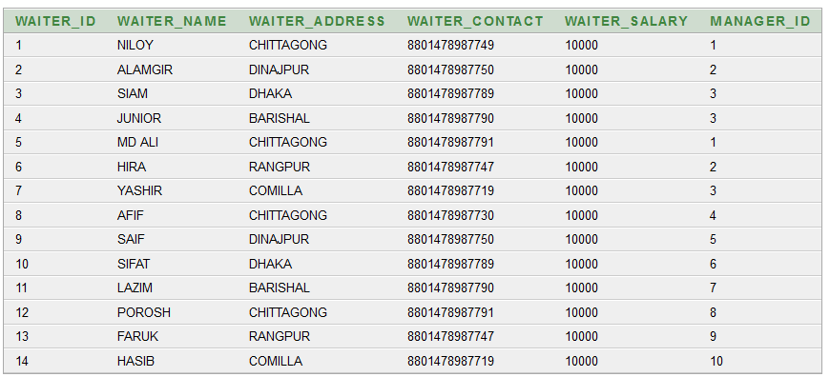

PAYMENT

INSERT INTO Payment (payment_id ,amount,paid_by,dates,customer_id) VALUES(paymentseq.NEXTVAL, 520,'RAYHAN', '08DEC 2022', 1);

INSERT INTO Payment (payment_id ,amount,paid_by,dates,customer_id) VALUES(paymentseq.NEXTVAL, 120,'TAMIM', '08DEC 2022', 2);

INSERT INTO Payment (payment_id ,amount,paid_by,dates,customer_id) VALUES(paymentseq.NEXTVAL, 450,'NIHAB', '09DEC 2022', 3);

INSERT INTO Payment (payment_id ,amount,paid_by,dates,customer_id) VALUES(paymentseq.NEXTVAL, 550,'LIMA', '09DEC 2022', 4);

INSERT INTO Payment (payment_id ,amount,paid_by,dates,customer_id) VALUES(paymentseq.NEXTVAL, 600,'HIMEL', '10DEC 2022', 5);

INSERT INTO Payment (payment_id ,amount,paid_by,dates,customer_id) VALUES(paymentseq.NEXTVAL, 300,'AKASH', '10DEC 2022', 6);

INSERT INTO Payment (payment_id ,amount,paid_by,dates,customer_id) VALUES(paymentseq.NEXTVAL, 200,'RIVA', '10DEC 2022', 7);

INSERT INTO Payment (payment_id ,amount,paid_by,dates,customer_id) VALUES(paymentseq.NEXTVAL, 1000,'JIBON', '11DEC 2022', 8);

INSERT INTO Payment (payment_id ,amount,paid_by,dates,customer_id) VALUES(paymentseq.NEXTVAL, 900,'FAHIM', '11DEC 2022', 9);

INSERT INTO Payment (payment_id ,amount,paid_by,dates,customer_id) VALUES(paymentseq.NEXTVAL, 700,'MEHEDI', '11DEC 2022', 10);

INSERT INTO Payment (payment_id ,amount,paid_by,dates,customer_id) VALUES(paymentseq.NEXTVAL, 300,'SHAMMO', '11DEC 2022', 11);

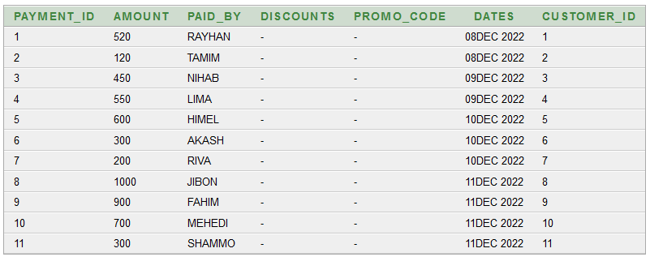

RATING

INSERT INTO Rating (Rating_id ,Scores,Remarks,Customer_id,Food_id) VALUES(ratingseq.NEXTVAL, 9,'Delicious food',1,8);

INSERT INTO Rating (Rating_id ,Scores,Remarks,Customer_id,Food_id) VALUES(ratingseq.NEXTVAL, 9,'Delicious food',2,9);

INSERT INTO Rating (Rating_id ,Scores,Remarks,Customer_id,Food_id) VALUES(ratingseq.NEXTVAL, 9,'Awesome experience',4,17);

INSERT INTO Rating (Rating_id ,Scores,Remarks,Customer_id,Food_id) VALUES(ratingseq.NEXTVAL, 9,'Good',9,10);

INSERT INTO Rating (Rating_id ,Scores,Remarks,Customer_id,Food_id) VALUES(ratingseq.NEXTVAL, 9,'Best in town',5,11);

INSERT INTO Rating (Rating_id ,Scores,Remarks,Customer_id,Food_id) VALUES(ratingseq.NEXTVAL, 9,'Icy',3,20);

INSERT INTO Rating (Rating_id ,Scores,Remarks,Customer_id,Food_id) VALUES(ratingseq.NEXTVAL, 9,'what a surprise!',10,20);

INSERT INTO Rating (Rating_id ,Scores,Remarks,Customer_id,Food_id) VALUES(ratingseq.NEXTVAL, 9,'Great food',6,7);

INSERT INTO Rating (Rating_id ,Scores,Remarks,Customer_id,Food_id) VALUES(ratingseq.NEXTVAL, 9,'Best flavour',7,16);

INSERT INTO Rating (Rating_id ,Scores,Remarks,Customer_id,Food_id) VALUES(ratingseq.NEXTVAL, 9,'Nice behaviour',8,12);

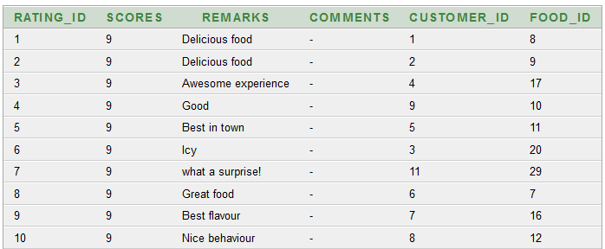

ORDERS

INSERT INTO Orders VALUES(orderseq.NEXTVAL, '08-DEC-2022', 520, 6,1);

INSERT INTO Orders VALUES(orderseq.NEXTVAL, '09-DEC-2022', 120, 5,1);

INSERT INTO Orders VALUES(orderseq.NEXTVAL, '09-DEC-2022', 450, 2,1);

INSERT INTO Orders VALUES(orderseq.NEXTVAL, '09-DEC-2022', 220, 2,1);

INSERT INTO Orders VALUES(orderseq.NEXTVAL, '09-DEC-2022', 320, 6,1);

INSERT INTO Orders VALUES(orderseq.NEXTVAL, '09-DEC-2022', 260, 5,1);

INSERT INTO Orders VALUES(orderseq.NEXTVAL, '09-DEC-2022', 899, 6,1);

INSERT INTO Orders VALUES(orderseq.NEXTVAL, '09-DEC-2022', 720, 2,1);

INSERT INTO Orders VALUES(orderseq.NEXTVAL, '09-DEC-2022', 120, 2,1);

INSERT INTO Orders VALUES(orderseq.NEXTVAL, '10-DEC-2022', 1820, 5,1);

INSERT INTO Orders VALUES(orderseq.NEXTVAL, '11-DEC-2022', 2520, 5,1);

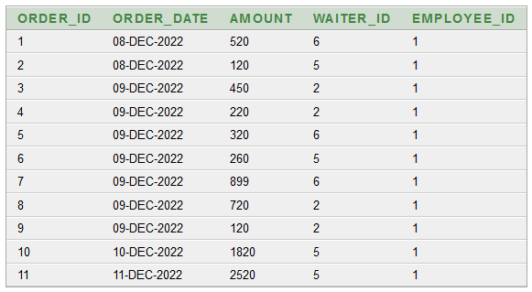

CMR

INSERT INTO CMR VALUES(1,1,8);

INSERT INTO CMR VALUES(2,2,9);

INSERT INTO CMR VALUES(3,4,17);

INSERT INTO CMR VALUES(4,9,10);

INSERT INTO CMR VALUES(5,5,11);

INSERT INTO CMR VALUES(6,3,20);

INSERT INTO CMR VALUES(7,10,20);

INSERT INTO CMR VALUES(8,6,7);

INSERT INTO CMR VALUES(9,7,16);

INSERT INTO CMR VALUES(10,8,12);

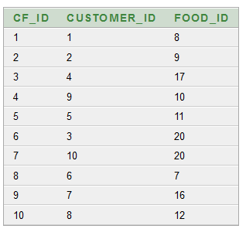

CONSTRAINTS ADDING

MENU

ALTER TABLE Menu MODIFY Price NOT NULL;

CUSTOMER

ALTER TABLE Customer MODIFY Order_id NOT NULL;

alter table Customer add constraint ofk foreign key (Order_id) references orders(Order_id);

MANAGER

ALTER TABLE Manager MODIFY Manager_salary NOT NULL;

WAITER

alter table Waiter add constraint mfk foreign key (Manager_id) references Manager(Manager_id);

PAYMENT

alter table Payment add constraint cfk foreign key (Customer_id) references Customer(Customer_id);

RATING

alter table Rating add constraint rfk foreign key (Customer_id) references Customer(Customer_id);

alter table Rating add constraint rmfk foreign key (Food_id) references Menu(Food_id);

ORDERS

alter table Orders add constraint wfk foreign key (Waiter_id) references Waiter(Waiter_id);

alter table Orders add constraint efk foreign key (Employee_id) references Employee(Employee_id);

CMR

alter table CMR add constraint cufk foreign key (Customer_id) references Customer(Customer_id);

alter table CMR add constraint fofk foreign key (Food_id) references Menu(Food_id);

QUERY WRITING

JOINING

EQUIJOIN

1. select m.manager_id, m.manager_name, w.waiter_id, w.waiter_name, w.manager_id from manager m, waiter w where m.manager_id = w.manager_id

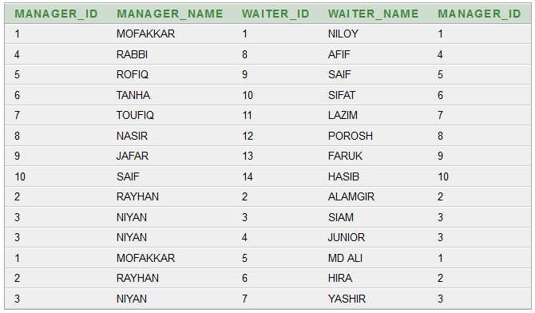

1. select c.customer_name, c.customer_address, c.order_id, o.order_date, o.amount, o.waiter_id, w.waiter_name from customer c, orders o, waiter w where c.order_id = o.order_id and o.waiter_id = w.waiter_id

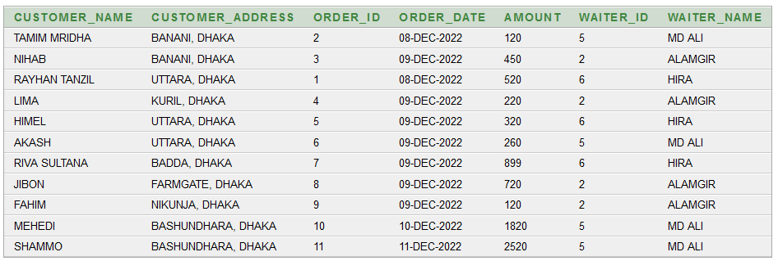

OUTERJOIN

1. select w.waiter_id, w.waiter_name, m.manager_id from waiter w, manager m where w.manager_id(+) = m.manager_id order by w.manager_id

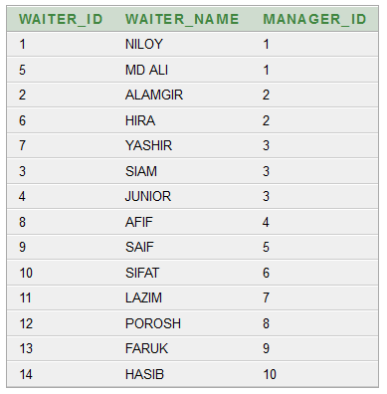

1. select w.waiter_name, w.waiter_id, o.order_id, o.amount from orders o, waiter w where w.waiter_id = o.waiter_id (+)

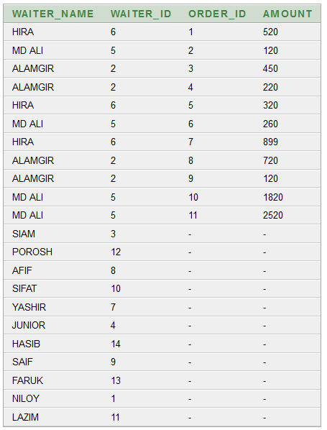

SELFJOIN

1. select distinct w.waiter_id || ' Works for ' || m.manager_id from waiter w, waiter m where w.manager_id = m.manager_id

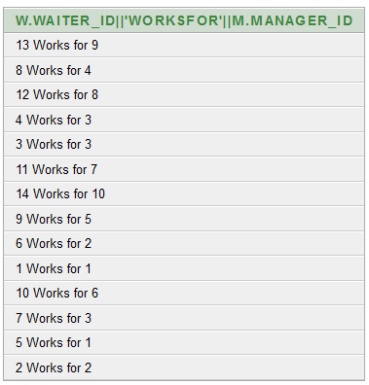

1. select e.employee_name ||' WORKS AS '|| r.role as info from employee e, employee r where e.employee_id = r.employee_id

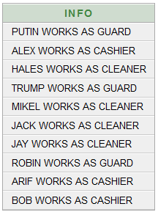

NON_EQUIJOIN

1. select distinct e.employee_name from waiter w, employee e where w.waiter_salary>=10000

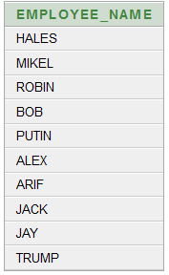

1. select distinct o.order_date, o.amount from orders o, waiter w where w.waiter_id between 5 and 7

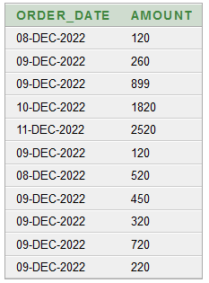

SUBQUERY

1. select * from menu where food_id in (select food_id from menu where price>200)
2. select * from customer where customer_id = any (select customer_id from customer where customer_address = 'UTTARA, DHAKA')
3. select * from employee where employee_salary > all (select employee_salary from employee where role='CLEANER')
4. select * from waiter where waiter_address <> all (select waiter_address from waiter where manager_id = 2)
5. select * from orders where order_id = any (select order_id from orders where amount>300)

SINGLE ROW FUNCTION

1. select * from employee where LOWER(role) = 'guard'
2. select * from rating where UPPER(remarks) = 'GOOD'
3. select * from menu where INITCAP(food_name) = 'Mint Icecream'
4. select employee_name, CONCAT(employee_name,role), LENGTH(role) from employee where employee_address = 'DHAKA'
5. select TO_CHAR(employee_salary, '$99,999') salary from employee where employee_name='ALEX'

GROUP FUNCTION

1. select MIN(employee_salary) from employee where employee_address = 'DHAKA'
2. select MAX(employee_salary) from employee where employee_address = 'DHAKA'
3. select COUNT(*) from waiter where manager_id = 2
4. select AVG(employee_salary) from employee group by role
5. select role, SUM(employee_salary) from employee where employee_name<>'JACK' group by role having SUM(employee_salary) >5000 order by SUM(employee_salary) desc

VIEW

create or replace view menuview

as

select m.food_name, m.food_status, m.price, r.remarks, r.food_id from menu m, rating r

where m.food_id = r.food_id

select * from menuview

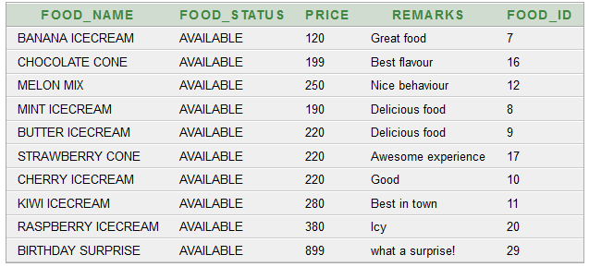

SEQUENCE

create sequence menuseq

start with 1

increment by

maxvalue 500

NOCACHE

NOCYCLE

GENERAL QUERY

1. select employee_name from employee where employee_name like '%L%' ;
2. select customer_name, order_id from customer where customer_id in (5,9,10);
3. select food_name, food_id, price from menu where food_status = 'UNAVAILABLE' ;
4. select employee_id, employee_name, employee_salary from employee where employee_id<>90 ;
5. select manager_id, manager_name ||' FROM '|| manager_address as info from manager;

THE END